**Sentiment Analysis – UPS**

Histograms

Day 1 – 11-30-2014

No. Of Tweets -> 200

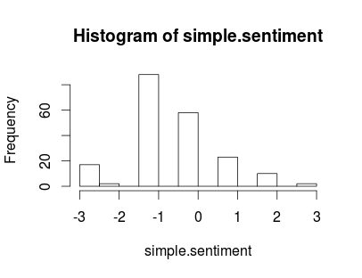

Day 2 – 12-01-2014

No. Of Tweets -> 200

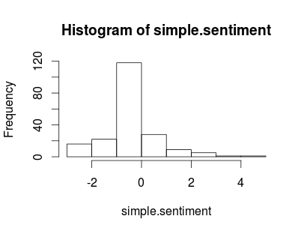

Day 3 – 12-02-2014

No. Of Tweets -> 200

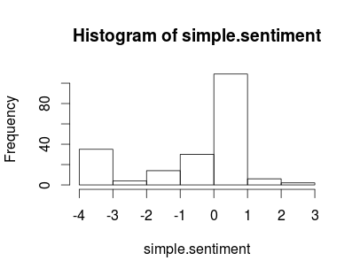

Day 4 – 12-03-2014

No. Of Tweets -> 200

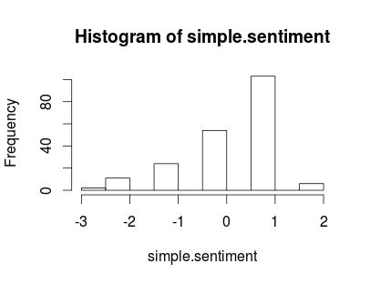

Day 5 – 12-04-2014

No. Of Tweets -> 200

